AWS CloudWatch EC2 Monitoring Lab

PART 1 — Launch an EC2 Instance
Step 1 — Configure EC2 Instance
The screenshot shows the Launch an instance page in the AWS EC2 console.
Configure the following:
- Name: cloudwatch-lab-server
- AMI: Amazon Linux 2023
- Instance type: t2.micro or t3.micro
- Key pair: cloudwatch-lab-key
- Network: Default VPC and subnet
- Security group: Allow SSH from My IP
- Storage: Default 8 GiB gp3
Explanation
This step creates a virtual Linux server using Amazon EC2. The EC2 instance will later generate CPU metrics that CloudWatch will monitor.
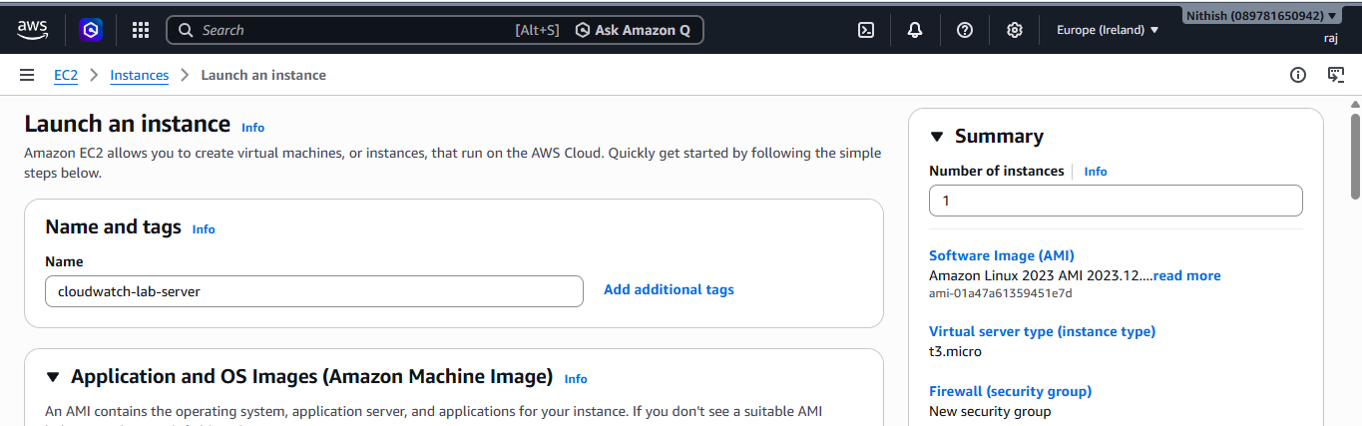

EC2 Instance Running
Step 2 — Verify the Instance
After clicking Launch instance, go to View all instances.
The screenshot shows:
Instance State → Running
Status Check → 2/2 checks passed
Explanation
This confirms that the EC2 virtual machine has successfully started and passed AWS's basic status checks.
The instance is now ready to be monitored by CloudWatch.
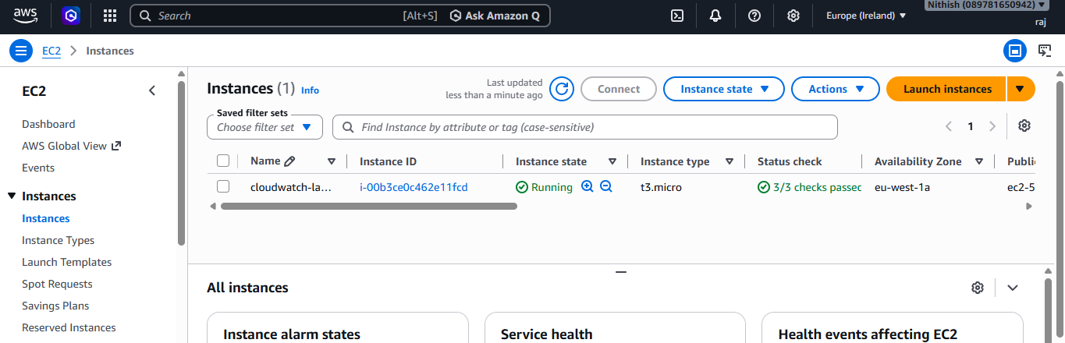

PART 2 — Open CloudWatch
Step 3 — Connect to the EC2 Server
The screenshot shows the Connect to instance page.
It displays:
- IPv4 address
- Connection options
- Username
- Connect button
Explanation
This page allows you to access the Linux terminal of your EC2 instance through the AWS console.
You will use this terminal later to generate CPU load.
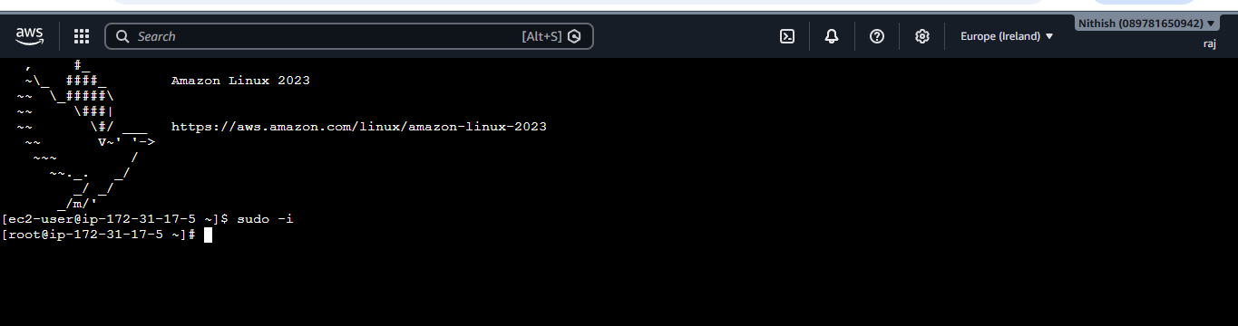

Step 4 — Open CloudWatch
From the AWS Console:
AWS Console
↓
Search
↓
CloudWatch
Click CloudWatch.
Explanation
CloudWatch is the AWS monitoring service. It collects and displays metrics from AWS resources such as EC2.
Your lab now moves from creating the server to monitoring the server.
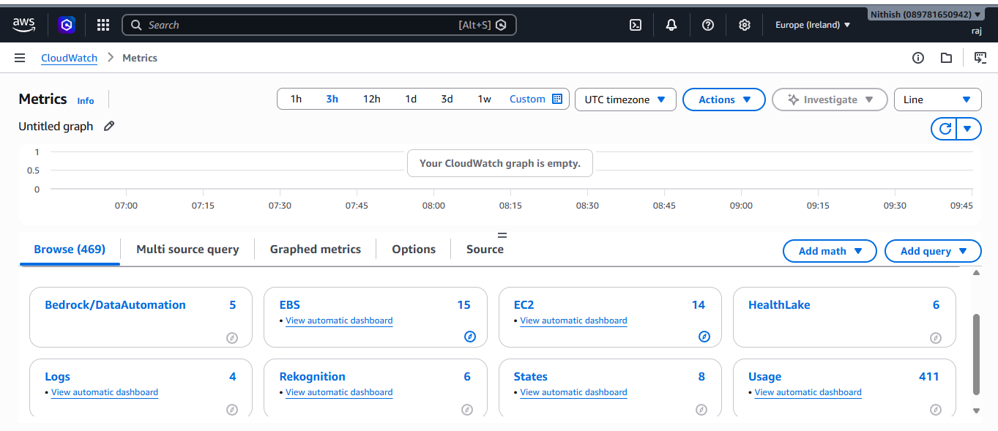

PART 3 — Find EC2 CPU Metric
📷 Screenshot 5 — CloudWatch Metrics
Step 5 — Open All Metrics
Inside CloudWatch:
CloudWatch
↓
Metrics
↓
All metrics
Explanation
The Metrics section contains measurements collected from AWS resources.
For EC2, CloudWatch automatically receives basic metrics, including CPUUtilization.
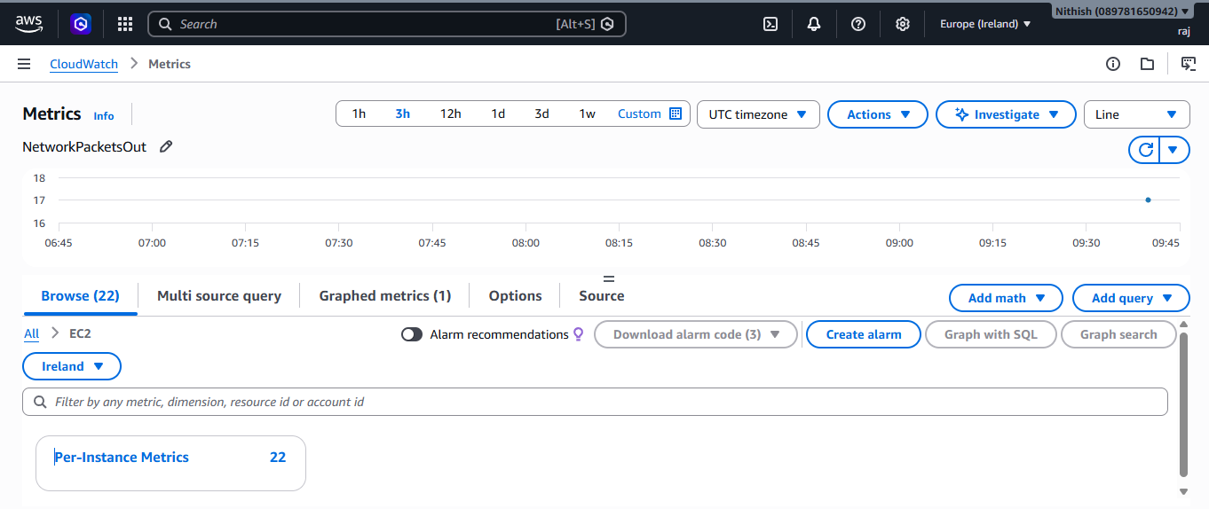

Step 6 — Select EC2
Choose:
EC2
↓
Per-Instance Metrics
You should see your EC2 instance:
cloudwatch-lab-server
Explanation
Per-Instance Metrics displays metrics belonging to individual EC2 instances.
This allows you to monitor one particular server rather than EC2 resources in general.
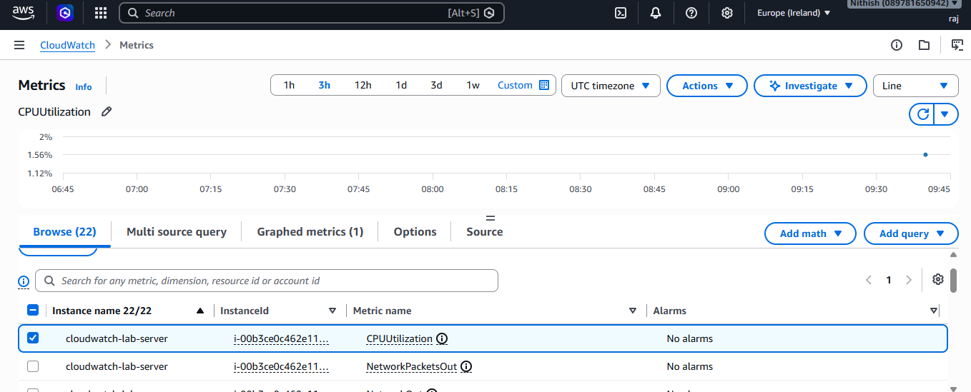

Step 7 — Select CPUUtilization
Select:
CPUUtilization
Then click:
Graph
You will see a CPU utilization graph.
Explanation
The graph shows how much CPU capacity your EC2 instance is using over time.
For example:
CPU = 10% → Low CPU usage
CPU = 50% → Moderate usage
CPU = 80% → High usage
CPU = 90%+ → Very high usage
The document notes that these values are examples, not universal healthy/unhealthy limits. The correct threshold depends on the application.

Step 8 — Open Alarms
Go to:
CloudWatch
↓
Alarms
↓
Create alarm
Explanation
A CloudWatch Alarm watches a metric and changes state when a specified condition is met.
In this lab, the alarm will watch:
EC2 CPUUtilization
and trigger when CPU becomes greater than the configured threshold.
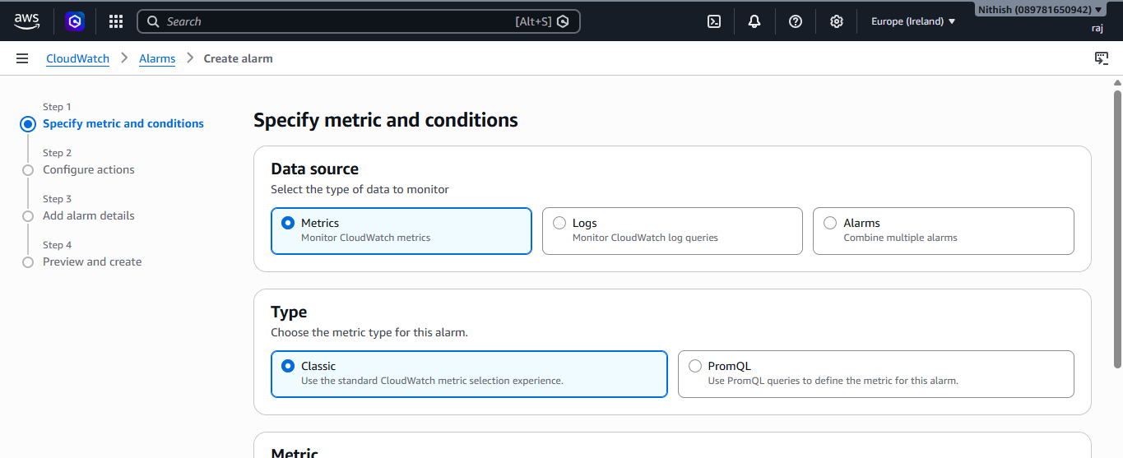

📷 Screenshot 9 — Select CPU Metric for Alarm
Step 9 — Select Metric
Choose:
Select metric
↓
EC2
↓
Per-Instance Metrics
↓
CPUUtilization
↓
Select your instance
Then click:
Select metric
Explanation
Here, you are telling CloudWatch:
"Create an alarm based on the CPU utilization of this particular EC2 instance."
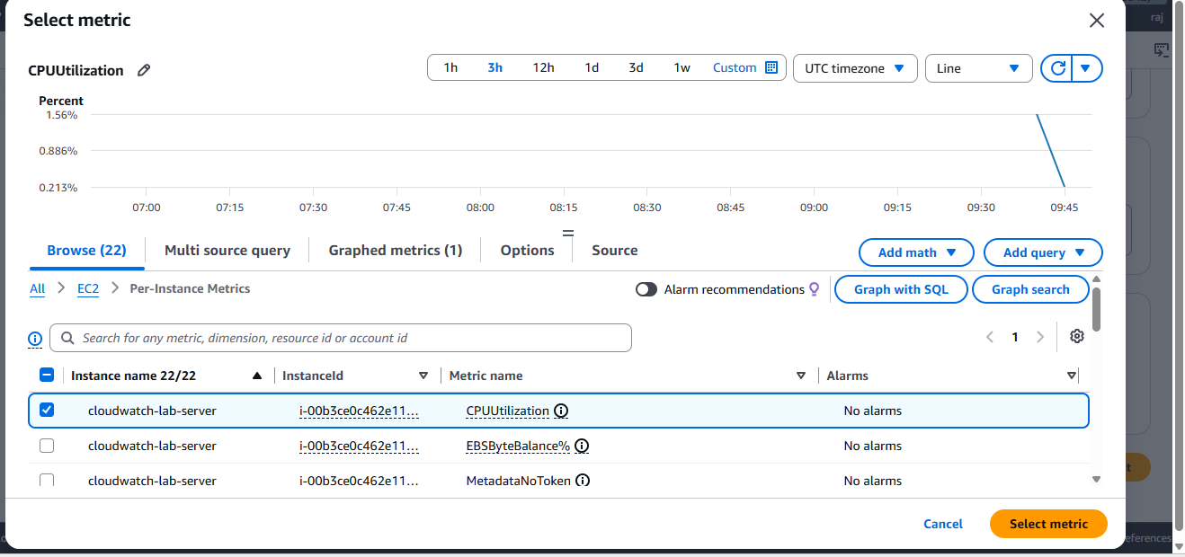

📷 Screenshot 10 — Configure Metric
Step 10 — Configure Statistic and Period
Set:
Statistic → Average
Period → 5 minutes
Explanation
Average means CloudWatch uses the average CPU utilization for the selected period.
A 5-minute period means the alarm evaluates the metric over 5-minute intervals.
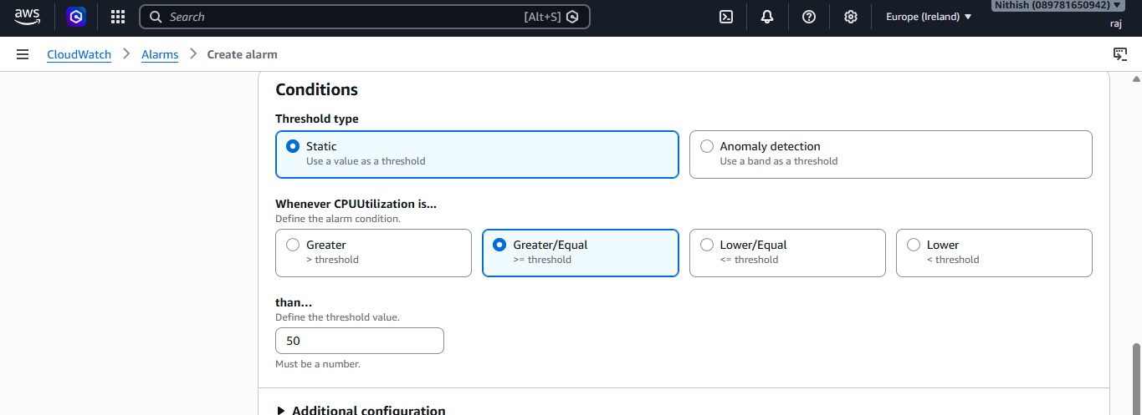

Step 11 — Set the Threshold
Under Conditions:
Threshold type → Static
Condition → Greater than
Value → 80
Therefore:
CPUUtilization > 80%
Explanation
This tells CloudWatch:
If the EC2 CPU utilization goes above 80%, the alarm should enter the ALARM state.

📷 Screenshot 12 — Alarm Configuration
Step 12 — Verify Alarm Condition
The configuration should look like:
Metric:
CPUUtilization

Statistic:
Average

Period:
5 minutes

Condition:
Greater than 80%
The logic is:
EC2 Instance
↓
CPUUtilization
↓
CPU > 80%
↓
CloudWatch Alarm
↓
ALARM state
Explanation
This screenshot represents the complete monitoring condition before adding the notification.
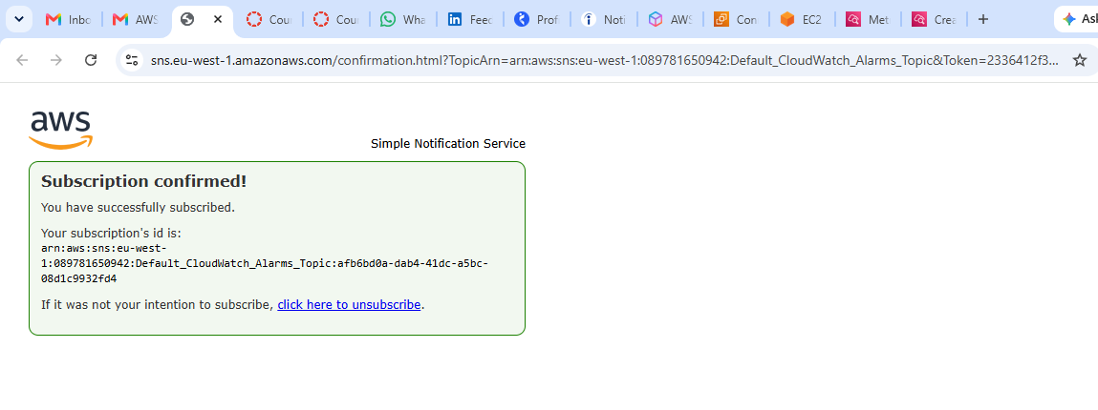

PART 9 — Create SNS Notification
📷 Screenshot 13 — Configure SNS Notification
Step 13 — Add Notification
Under Alarm state trigger, select:
In alarm
Then select or create an SNS topic.
Example:
SNS Topic → cloudwatch-alerts
Email → your email address
Explanation
SNS (Simple Notification Service) is used to send the alarm notification to your email.
The complete flow becomes:
EC2
↓
CPU > 80%
↓
CloudWatch Alarm
↓
SNS
↓
Email
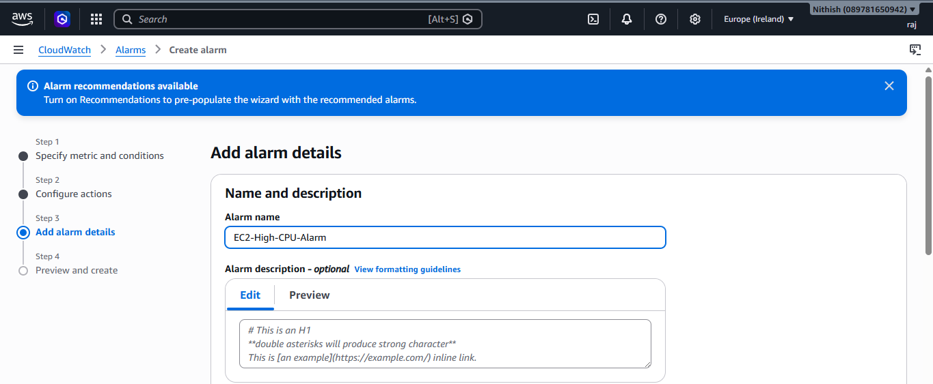

PART 10 — Confirm SNS Email
📷 Screenshot 14 — SNS Subscription Confirmed
Step 14 — Confirm Email Subscription
AWS sends a confirmation email to the configured email address.
Open the email and click:
Confirm subscription
Explanation
SNS requires the email owner to confirm the subscription.
Until the subscription is confirmed, SNS will not deliver the CloudWatch alarm notifications to that email address.

PART 11 — Give the Alarm a Name
📷 Screenshot 15 — Alarm Name and Description
Step 15 — Add Alarm Details
Enter:
Alarm name:
EC2-High-CPU-Alarm
Example description:
Alert when EC2 CPU utilization is greater than 80 percent.
Then click:
Next
Explanation
The alarm name makes it easy to identify what the alarm monitors.
Here:
EC2-High-CPU-Alarm
clearly indicates that the alarm monitors high CPU usage on an EC2 instance.

PART 12 — Create and Check Alarm
📷 Screenshot 16 — Alarm Successfully Created
Step 16 — Create Alarm
Review all the configuration settings.
Click:
Create alarm
The screenshot shows that the alarm has been successfully created.
Explanation
At this point, the CloudWatch alarm is active and ready to monitor the EC2 CPU metric.
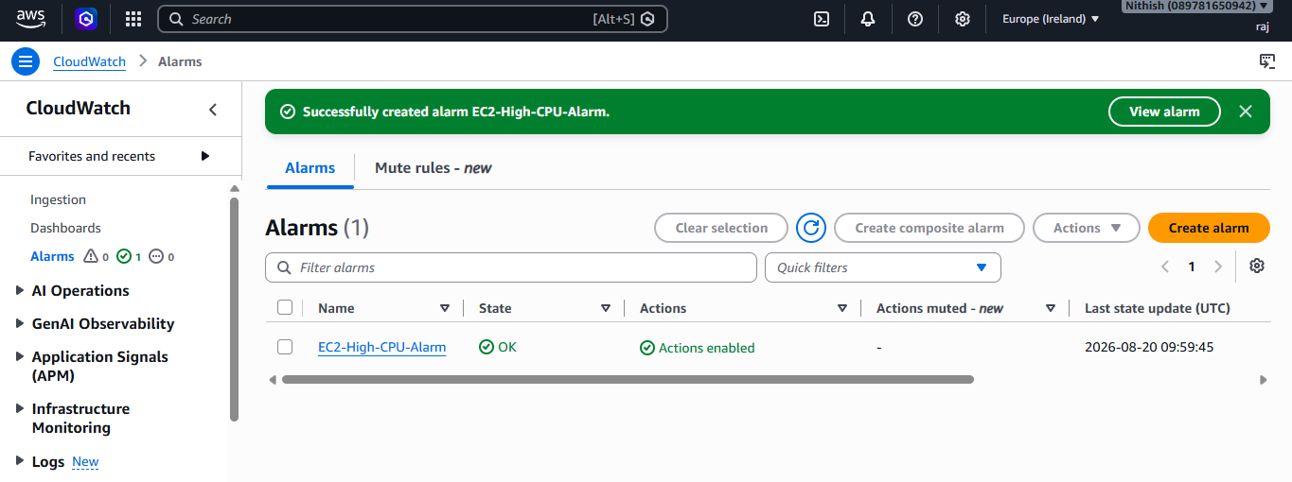

📷 Screenshot 17 — Alarm in OK State
Step 17 — Check Alarm State
Go to:
CloudWatch
↓
Alarms
You should see:
EC2-High-CPU-Alarm
State → OK
Explanation
OK means the current CPU utilization is below the configured alarm threshold.
So currently:
CPU < 80%
↓
Alarm = OK

PART 13 — Generate High CPU Load
📷 Screenshot 18 — Generate CPU Load
Step 18 — Run CPU Load Command
The screenshot shows commands running inside the EC2 Linux terminal, such as:
seq 1000000000 > /dev/null &
Multiple processes are started.
Explanation
The purpose of this command is to create a large amount of CPU work.
The idea is:
Normal EC2
↓
Low CPU usage
↓
Run CPU-intensive processes
↓
CPU usage increases
This is done so you can test whether the CloudWatch alarm actually detects high CPU usage.
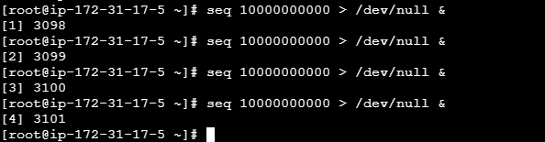

PART 14 — Alarm Changes to ALARM
📷 Screenshot 19 — Alarm in ALARM State
The screenshot shows:
EC2-High-CPU-Alarm
State → ALARM
Explanation
The CPU utilization has crossed the configured threshold.
The monitoring flow is now:
CPU utilization
↓
CPU > 80%
↓
CloudWatch detects condition
↓
Alarm changes
OK → ALARM
↓
SNS notification
↓
Email sent
This is the main purpose of the lab.
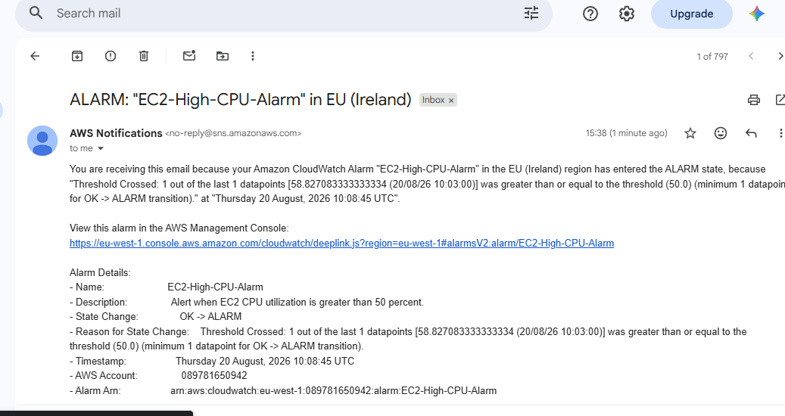

📷 Screenshot 20 — CPU Utilization Around 67.1%
The screenshot shows a CloudWatch graph with CPU utilization around:
67.1%
Explanation
This graph shows the CPU metric increasing over time.
The important concept is that CloudWatch continuously collects the EC2 CPU metric, allowing you to see the change visually.
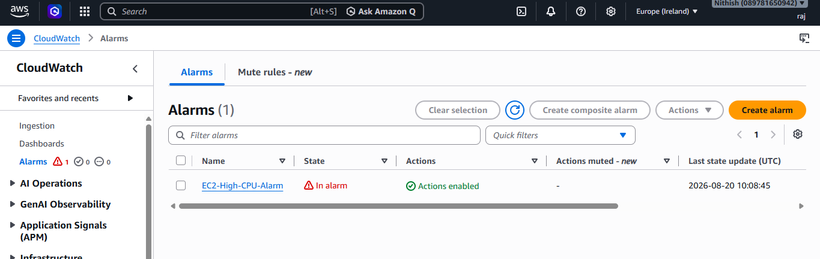

PART 15 — CloudWatch Overview
📷 Screenshot 21 — CloudWatch Alarm Dashboard
The screenshot shows the CloudWatch Overview page.
You can see the alarm:
EC2-High-CPU-Alarm
and its CPU graph.
Explanation
The overview gives you a centralized view of the monitoring status.
It allows you to quickly identify whether an AWS service has an active alarm.

PART 16 — Stop CPU Load
📷 Screenshot 22 — Terminal Processes
The final terminal screenshot shows the CPU-intensive processes being terminated.
Commands such as:
killall seq
are used to stop the processes.
Explanation
Once the CPU-intensive processes are stopped, CPU usage should gradually decrease.
The monitoring cycle is therefore:
Generate CPU load
↓
CPU increases
↓
CloudWatch detects high CPU
↓
Alarm → ALARM
↓
SNS sends email
↓
Stop CPU load
↓
CPU decreases
↓
Alarm can return to OK
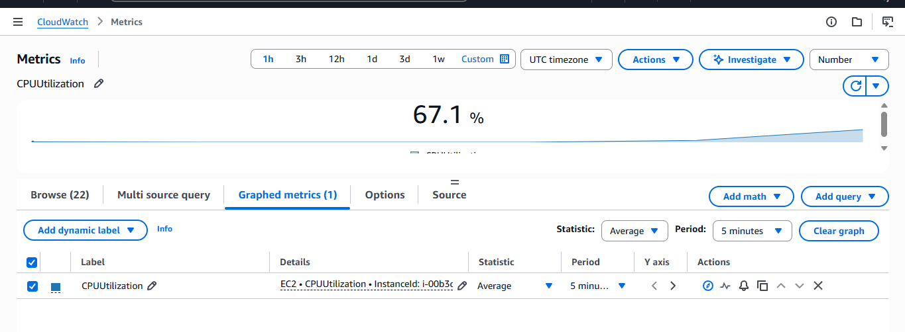

📷 Final Screenshot — Alarm Returns to OK
The final screenshot shows:
EC2-High-CPU-Alarm
State → OK
Explanation
After the CPU load is stopped, CPU utilization decreases below the configured threshold.
Therefore, CloudWatch recognizes that the alarm condition is no longer true and the alarm returns to OK.
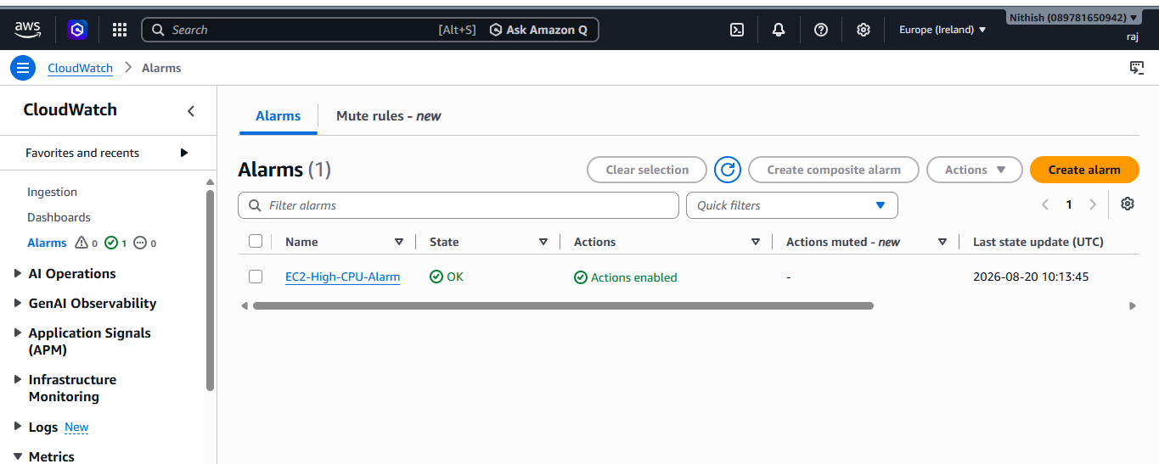

🔥 Complete Lab Architecture
Your entire lab can be understood with this simple flow:
AWS
│
▼
┌──────────────┐
│ EC2 Instance │
│ Linux │
└──────┬───────┘
│
│ CPUUtilization
▼
┌─────────────────┐
│ CloudWatch │
│ Metric │
└────────┬────────┘
│
│ CPU > 80%
▼
┌─────────────────┐
│ CloudWatch Alarm│
└────────┬────────┘
│
│ ALARM
▼
┌─────────────────┐
│ SNS │
└────────┬────────┘
│
▼
📧 Your Email

